Hey, I’m Nikhil Roy

Linkedin - https://www.linkedin.com/in/nikhil-kumar-roy/

**SQL Case Study 1: Data Mart Analysis**



**INTRODUCTION:**

Data Dart is my latest venture and I want your help to analyze the sales and performance of my venture. In June 2020 - large-scale supply changes were made at Data Mart. All Data Mart products now use sustainable packaging methods in every single step from the farm all the way to the customer.

I need your help to quantify the impact of this change on the sales performance for Data Mart and its separate business areas.

**SCHEMA USED: WEEKLY_SALES TABLE**

|  |  |
| --- | --- |
| **Column name** | **Data type** |
| week_date | date |
| region | varchar(20) |
| platform | varchar(20) |
| segment | varchar(10) |
| customer | varchar(20) |
| transactions | int |
| sales | int |

**CASE STUDY QUESTIONS**

## **A.** **Data Cleansing Steps**

In a single query, perform the following operations and generate a new table in the data_mart schema named clean_weekly_sales:

1. Add a week_number as the second column for each week_date value, for example any value from the 1st of January to 7th of January will be 1, 8th to 14th will be 2, etc.

2. Add a month_number with the calendar month for each week_date value as the 3rd column

3. Add a calendar_year column as the 4th column containing either 2018, 2019 or 2020 values

4. Add a new column called age_band after the original segment column using the following mapping on the number inside the segment value

|  |  |
| --- | --- |
| **segment** | **age_band** |
| **1** | Young Adults |
| **2** | Middle Aged |
| **3 or 4** | Retirees |

5. Add a new demographic column using the following mapping for the first letter in the segment values:

segment | demographic |  
 C | Couples |  
 F | Families |

6. Ensure all null string values with an "unknown" string value in the original segment column as well as the new age_band and demographic columns

7. Generate a new avg_transaction column as the sales value divided by transactions rounded to 2 decimal places for each record

**Data Cleaning all Queries** 

CREATE TABLE clean_weekly_sales AS

SELECT

week_date,

week(week_date) AS week_number,

month(week_date) AS month_number,

year(week_date) AS calendar_year,

region,

platform,

CASE

WHEN segment = 'null' THEN 'Unknown'

ELSE segment

END AS segment,

CASE

WHEN right(segment, 1) = '1' THEN 'Young Adults'

WHEN right(segment, 1) = '2' THEN 'Middle Aged'

WHEN right(segment, 1) IN ('3', '4') THEN 'Retirees'

ELSE 'Unknown'

END AS age_band,

CASE

WHEN left(segment, 1) = 'C' THEN 'Couples'

WHEN left(segment, 1) = 'F' THEN 'Families'

ELSE 'Unknown'

END AS demographic,

customer_type,

transactions,

sales,

ROUND(sales / transactions,2) AS avg_transaction

FROM weekly_sales;

select * from clean_weekly_sales limit 10;

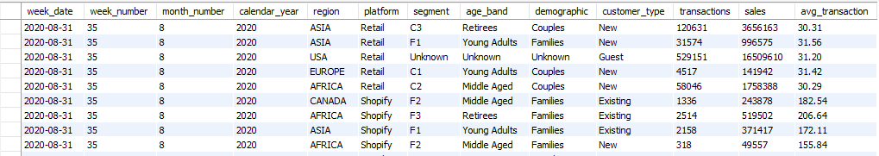

## 

## **B. Data Exploration**

1. Which week numbers are missing from the dataset?



create table seq100

(x int not null auto_increment primary key);

insert into seq100 values (),(),(),(),(),(),(),(),(),();

insert into seq100 values (),(),(),(),(),(),(),(),(),();

insert into seq100 values (),(),(),(),(),(),(),(),(),();

insert into seq100 values (),(),(),(),(),(),(),(),(),();

insert into seq100 values (),(),(),(),(),(),(),(),(),();

insert into seq100 select x + 50 from seq100;

select * from seq100;

create table seq52 as (select x from seq100 limit 52);

select distinct x as week_day from seq52 where x not in(select distinct week_number from clean_weekly_sales);

select distinct week_number from clean_weekly_sales;

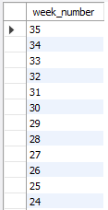 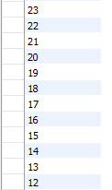

2. How many total transactions were there for each year in the dataset?



SELECT

calendar_year,

SUM(transactions) AS total_transactions

FROM clean_weekly_sales group by calendar_year;

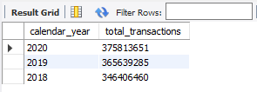

3. What are the total sales for each region for each month?



SELECT

month_number,

region,

SUM(sales) AS total_sales

FROM clean_weekly_sales

GROUP BY month_number, region

ORDER BY month_number, region;

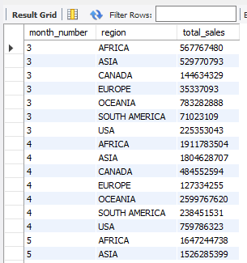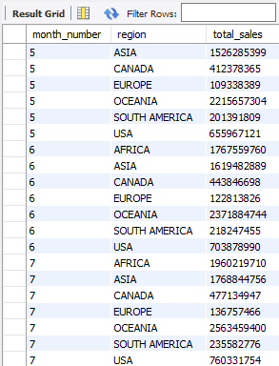

4. What is the total count of transactions for each platform



SELECT

platform,

SUM(transactions) AS total_transactions

FROM clean_weekly_sales

GROUP BY platform;

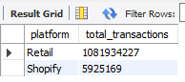

5. What is the percentage of sales for Retail vs Shopify for each month?



WITH cte_monthly_platform_sales AS (

SELECT

month_number,calendar_year,

platform,

SUM(sales) AS monthly_sales

FROM clean_weekly_sales

GROUP BY month_number,calendar_year, platform

)

SELECT

month_number,calendar_year,

ROUND(100 * MAX(CASE WHEN platform = 'Retail' THEN monthly_sales ELSE NULL END) /SUM(monthly_sales),2 ) AS retail_percentage,

ROUND(100 * MAX(CASE WHEN platform = 'Shopify' THEN monthly_sales ELSE NULL END) / SUM(monthly_sales),2 ) AS shopify_percentage

FROM cte_monthly_platform_sales

GROUP BY month_number,calendar_year

ORDER BY month_number,calendar_year;

6. What is the percentage of sales by demographic for each year in the dataset?



SELECT

calendar_year,

demographic,

SUM(SALES) AS yearly_sales,

ROUND((100 * SUM(sales)/ SUM(SUM(SALES)) OVER (PARTITION BY demographic)),2) AS percentage

FROM clean_weekly_sales

GROUP BY calendar_year, demographic

ORDER BY calendar_year, demographic;

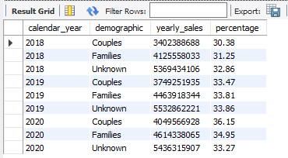

7. Which age_band and demographic values contribute the most to Retail sales?



SELECT

age_band,

demographic,

SUM(sales) AS total_sales

FROM clean_weekly_sales

WHERE platform = 'Retail'

GROUP BY age_band, demographic

ORDER BY total_sales DESC;



 

 